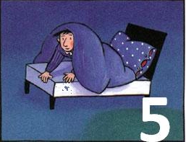
The Number Devil – Reading Notes Ch. 5
Take notes as you read chapter 5.

1. Poor Robert starts the 5th Night with nightmares… I think he might actually be hoping to meet the Number Devil again! When he finally does, coconuts become the focus!!!!
Draw a quick picture of the “triangles” they create, to be used for mathematics soon! (page 93).

2. Define triangle numbers and list the first ten. Below your list of ten, try the activity on page 98. Pick any number, I can show it to be the sum of either two or three triangle numbers.
Example: 51 = 15 + 36 83 = 10 + 28 + 45

3. What is the connection between triangle numbers and hopping numbers? Give an example that the Number Devil does not share.

4. Look at all the awsome math on pages 100 – 101! Can you explain in your own words the connections between the sum of the first 12 numbers and the 12th Triangle Number. Write it out if you need too!

5. Try the activity on page 103
If you’re not as hot as Robert, you might want to play with the cubes a bit before they melt. Just divide up the square numbers like this: (sketch the picture below). The numbers indicate the number of cubes within the lines you have drawn. What do you get if you add them together? The answer will look quite familiar.

6. Triangular Number Challenge: The Number Devil challenges Robert to, “Pick a number, any number, and I can show it to be the sum of either two or three triangle numbers.” Take on the challenge yourself. Find two or three triangle numbers that add up to the following numbers:

10 =
13 =
25 =
30 =
32 =
36 =
42 =
46 =
50 =
51 =
70 =
83 =
95 =
103 =

7. Can you add 2 adjacent triangular numbers to get a square number?
