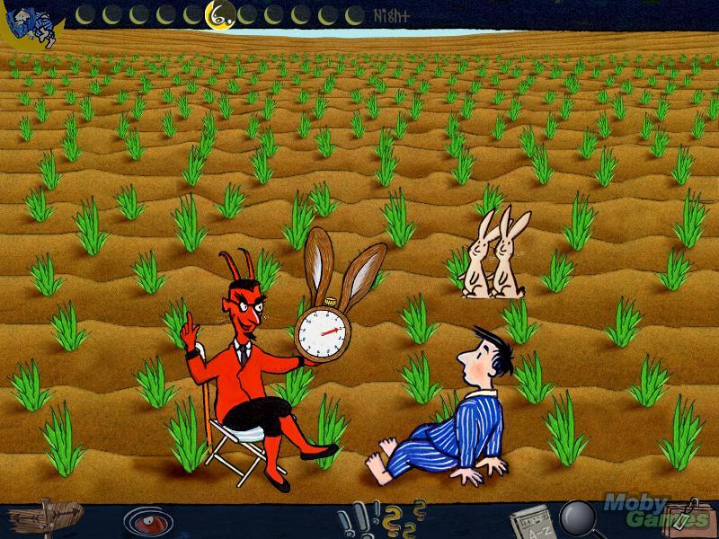
The Number Devil – Reading Notes Ch. 6
Take notes as you read chapter 6.

1. Complete the table with the Bonacci (Fibonacci ) numbers.

Term | 1 | 2 | 3 | 4 | 5 | 6 | 7 | 8 | 9 | 10 | 11 | 12 | 13 | 14 | 15 | 16
Value | 1 | 1 | 2

2. Describe the patterns.

3. Describe the bunny example and how it relates to the Fibonacci number pattern.

4. The book states that tree branches follow Fibonacci numbers. Do a web search and find at least 2 other examples in nature that follow the Fibonacci sequence.

5. If you still don’t believe that nature acts as if it knew how numbers work, turn to the tree on page 122. Maybe you found all those rabbits a bit confusing. Well, a tree can’t go romping through a field, so you won’t have any trouble counting its branches. Start from below, at the red line numbered one. It runs only through the trunk, as does line two. One line higher, at line three, the trunk has been joined by a branch. Keep going. How many branches are there by the time you reach the top, line nine?
