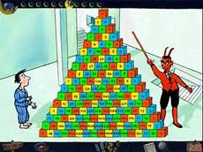
The Number Devil – Reading Notes Ch. 7
Take notes as you read chapter 7.

1. We are introduced to a “pyramid” of numbers of sorts…
The Number Devil makes connections to “hopping numbers”
and to “triangle numbers” – can you make those connections
below? (p.125-133)

2. Page 135 : You can say that again? You may think this is only good for giving you a headache. Wrong! Quite the contrary, in fact. It’s good for lazy-bones who don’t want to both with long sums. Let’s say you need to find the sum of the sums. All you have to do is run your finger down the third diagonal --- the one that goes 1, 3, 6, 10, and son on --- until you come to the twelfth cube. Then you find the number just below it and toward the center. What is it?
By doing so, you have saved yourself the effort of working out what
1 + 3 + 6 + 10 + 15 + 21 + 28 + 36 + 45 + 55 + 66 + 78 comes to.

Illustrate and describe what the Number Devil means by this – using your own words and the information and picture on pages 134-135. (Test his theory)

3. The Number Devil explains other patterns on pages 136 – 142, choose one of his patterns and sketch / explain / draw it in your own words.

4. Are any of you curious about what kind of pattern we get when we light up all the numbers that can be divided by four? You don’t need to be a number devil to figure it out. Just use the triangle below (same as page 146) and color in all the numbers that occur in the fours column of the multiplication table. With numbers above forty-eight use your calculator: enter the number, then /4, and =, and see whether it comes out even.
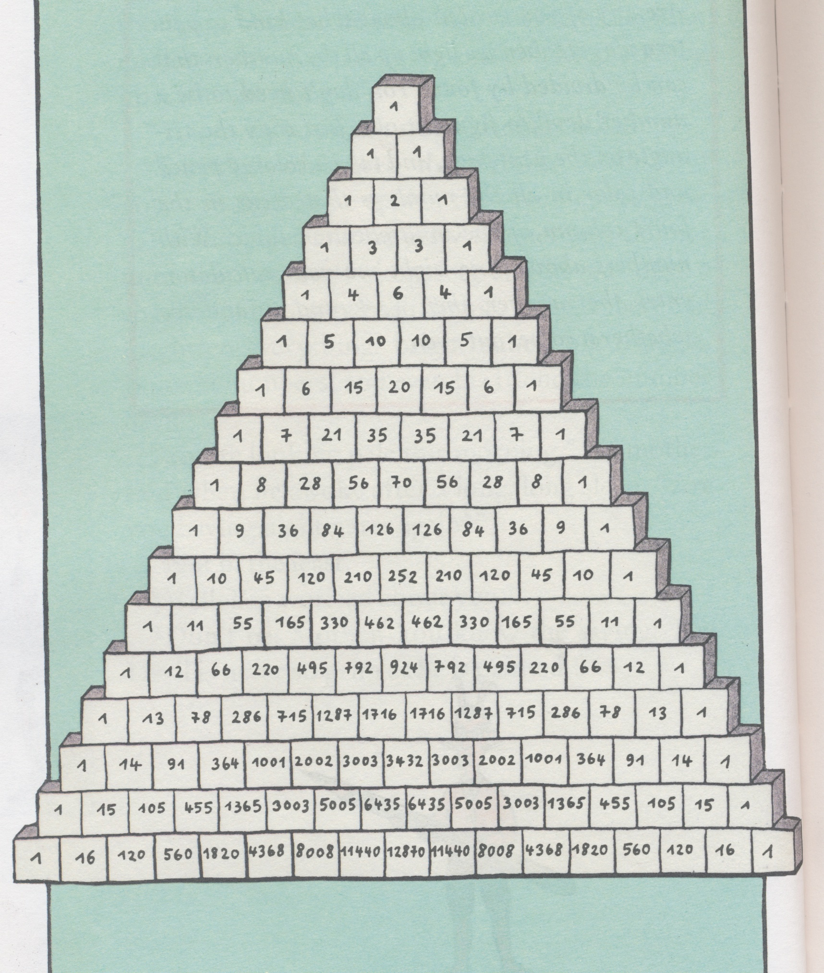

5. Finish Pascal’s Triangle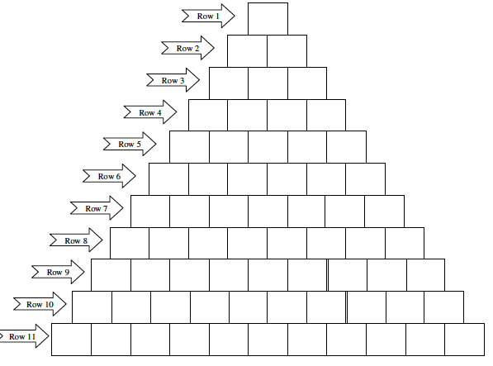

There are many patterns found in Pascal’s Triangle. Explain your favorite!

