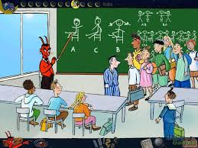
The Number Devil – Reading Notes Ch. 8
Take notes as you read chapter 8.

1. Robert has a dream about school, although the Number Devil is the “teacher,” not Mr. Bockel. We meet Al, Betsy and Charlie. Robert tries all of the possibilities of seating arrangements for ABC (page 152), can you create a similar problem using SIX of your classmates?

2. What does 4 vroom mean? What is the mathematical term for “vroom!”

3. Hand shakes! There are several “famous” math problems that have to do with hand shake possibilities. You are introduced to one on page 158. Can you explain in your own words the connections between Handshakes and Coconuts / Triangle Numbers?

** Can you explain the drawings on page 160? How do they relate to handshakes? Draw an example below.

4. What is the Broom-Brigade-Trio (page 165) and how can you explain it using the “cubes” on page 166? We know a lot about the picture on page 166 now!
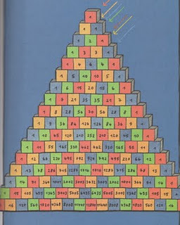

Factorials!
Fill in the blanks with the correct answers….

# of kids in class | Possibilitiies | # of ways to arrange the seats
1 | 1 | 1
2 |  | 2
3 | 1 x 2 x 3
4 | 1 x 2 x 3 x 4 | 24
5
6 | 1 x 2 x 3 x 4 x 5 x 6 | 720
7 |  | 5040
8
9 |  | 362,880
10 | 1 x 2 x 3 x 4 x 5 x 6 x 7 x 8 x 9 x 10 | 3,628,800
11
12

We have 21 students in our class could we change to different seats every day of the school year? Explain

