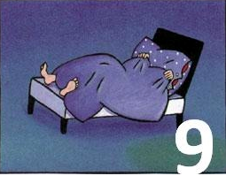
The Number Devil – Reading Notes Ch. 9
Take notes as you read chapter 8.

Number Review!!! List the first 10 numbers for each of the number
Sequences below:

1. Whole numbers: (pattern description: start @ 0 and add 1)

__0____, _______, _______, _______, _______, _______, _______, _______, _______, _______

2. Natural Numbers: (pattern description start @ ______ and _________________________)

___1___, __2_____, _______, _______, _______, _______, _______, _______, _______, _______

3. Odd Numbers: (pattern description start @ _____ and ____________________________)

__1____, _______, _______, _______, _______, _______, _______, _______, _______, _______

4. Prime numbers: (pattern description start @ ____ and ____________________)

___1___, _______, _______, _______, _______, _______, _______, _______, _______, _______

5. Fibonacci Numbers: (pattern description start @ ____ and ___________________________)

____1__, _______, _______, _______, _______, _______, _______, _______, _______, _______

6. Triangular Numbers (pattern description: start @ _____ and ____________________________)

___1___, _______, _______, _______, _______, _______, _______, _______, _______, _______

7. Powers of 2 (hopping): (pattern descriptions start @ _____ and _________________________)

___2___, _______, _______, _______, _______, _______, _______, _______, _______, _______

8. Factorial (Vroom!): (pattern description start @ ______ and __________________________)

____1__, _______, _______, _______, _______, _______, _______, _______, _______, _______

Fractions!

9. Talk about the fractions of 1 on page 182 and 183… What happens when you add them all up?

Solve

$\frac{1}{2}$ + $\frac{1}{4}$ + $\frac{1}{8}$ + $\frac{1}{16}$ + $\frac{1}{32}$ + $\frac{1}{64}$ =

Explain your answer!
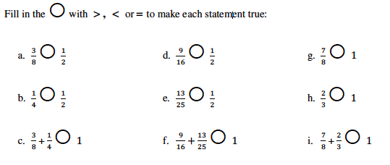
10.

11. Robert’s friend Al said, “5 out of 4 people are not good with fractions and I am one of them.” What is wrong with his statement?

